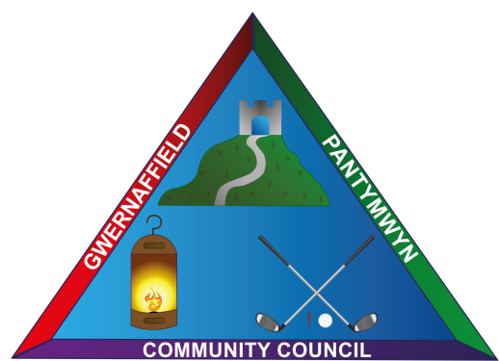

Gwernaffield and Pantymwyn Community Council
Annual Scarecrow Competition
Entries by 31 October 2023

Send your entry to: gwernaffieldclerk@outlook.com

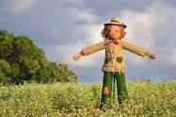
Prizes for 1st, 2nd and 3rd Best judged Scarecrow.
Please email your photo - include the scarecrow’s name/title and full address.
Scarecrows should be visible from the front of the house/garden from the roadside in Gwernaffield / Pantymwyn.
Thank you to The Rhual Dairy who is once again donating straw for participants in the competition. Collection from them weekend of 21st / 22nd October 10am – 4pm or from Ysgol Y Waun from 13th October
9.30am – 2.30pm.
We can’t wait to see this year’s entries! Good Luck / Pob Iwc.

