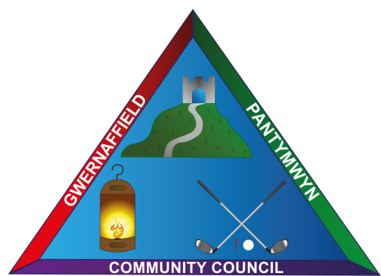

Dear Councillors / Annwyl Gynghorwyr
You are hereby summoned to a meeting of Gwernaffield and Pantymwyn Community Council,
6 March 2024, 6 Mawrth 2024 Mold Golf Club, Pantymwyn at 7.00pm.
Should any resident of the community council area wish to gain remote access to the meeting please contact the clerk to advise at least 3 working days in advance.
The meeting will consider the agenda items below.
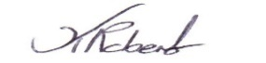
Kay Roberts
Clerk / Clerc

Agenda 6 March 2024 / 6 Mawrth 2024

- To record (A) Attendance (B) Apologies

- Declaration of interests

- Planning Matters

3a Planning Consultation Reference: FUL/000057/24 2 Fron Deg, Pantymwyn and receive amended correspondence and representation from the local applicant.

3b Planning Consultation Reference: FUL/000922/23 29 Tan Yr Hafod, Gwernaffield. Flintshire County Council have advised the applicant has appealed the decision to refuse planning.

3c. Flintshire County Council letter from planning should the community council wish to make representation to the hybrid planning committee on 13 March 2024, register before 11 March 2024 re. Ref: 061994 Proposal: Erection of residential development of 232 no. units together with associated public open space and infrastructure Site Location: Land to the north of Gwernaffield Road, Mold,Flintshire.

- To welcome Guest Speaker, Mr Darren Morris, Lead Officer for Play Development, Flintshire County Council to discuss community play provision options.

- To approve the minutes of the meeting held on the 7 February 2024.

- (A) To receive any matters arising from the February minutes. (B) To approve the minutes.

- To receive any Streetscene Matters.

Community Council Concern expressed to Streetscene in relation to full dog/litter bins in Pantymwyn and Gwernaffield and the delay in emptying these. Pot hole concerns.

- To discuss the bus stop in Pantymwyn Village, Cilcain Road and possible shelter options for those waiting at the bus stop.

- To approve the schedule of March Accounts for payment.
9a. To consider the updated asset register 2024/2025.
9b. To consider a draft reserves statement for 2024/2025.

- Clerk’s Update and Correspondence

10a. To receive a financial request for £50 from Pantymwyn Village Hall Management Committee to refresh the Planters by the Pantymwyn main village sign and Pen Y Fron Road, Planter, Pantymwyn.

10b. Community Alert emails circulated from North Wales Police.

10c. Website update on activities at Gwernaffield Church Hall.

- Representative Reports - Community Council Sub Committee Reports other meetings attended.

10a Environment and Community – Historical/Information Boards Project (Dwr Cymru).
- 10b Road Safety and Street Lighting - To review the 20mph limit in the villages and possible requests for changes via Flintshire County Council.
10c Events and newsletter update – Local Village Hero Community Award update
and Easter Window Dressing Competition 2024.

- The time and date of the next meeting 3 April 2024, Mawrth 2024 7.00pm at Mold Golf Club.

All future meetings for 2024 will now be held at Mold Golf Club.

