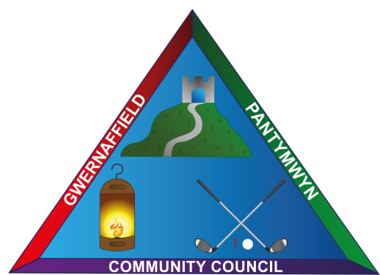
Dear Councillors / Annwyl Gynghorwyr
You are hereby summoned to a meeting of Gwernaffield and Pantymwyn Community Council,
5 October Hydref 2022 at 7.00pm / 5 Hydref 2022 at 7.00pm Ysgol Y Waun, Gwernaffield.
The meeting will consider the agenda items below.

Kay Roberts
Clerk / Clerc
Agenda 5 October 2022 / 5 Hydref 2022

- (A) Attendance (B) Apologies

- Declaration of interests

- To approve the minutes of the 7 September 2022 meeting.

- To receive any matters arising from the minutes.

- To welcome Peter Eton to his first meeting and to witness the signing of his declaration of office.

- To receive a verbal update from the Road Safety Committee.

- To receive a verbal update from the Ward County Councillors.

- To receive any Streetscene Matters.

- To receive a verbal update from the Events Group – to confirm the Christmas Senior Citizens Lunch at Mold Golf Club.

- To consider a request for a donation to the North Wales Wildlife Trust for their help and assistance toward the new planter in Gwernaffield Park / Playing Fields.

- To approve the schedule of October Accounts for Payment.

12a. To receive quarter 2 Bank reconciliation 1 July – 30 September 2022.

- Clerk’s Update and Correspondence

13a. To receive an update following the Summer Playscheme from Flintshire County Council.

13b One Voice Wales – Importance of Community and Town Councils in building resilient spaces for nature. Biodiversity Conference online 10.00am – 4.00pm.

14.(A) Planning Applications and (B) Decisions

- Planning Reference N0: 059235 (Non material amendment for planning application)
Location: 52 High Park, Gwernaffield, Mold, CH7 5EE.

Planning Reference N0: NMA/000401/22 (Non material amendment to planning permission ref: 063809. Location: Pant Y Garth, Pen Y Fron Road, Pantymwyn, Mold, CH7 5EF.

(B) Planning Application: 063697 – Erw Deg – Refused.
Planning Application: LDP/000243/22 Erw Deg – Certificate of lawfulness approved.

15. The time and date of the next meeting 9 November 2022, 7.00pm at Ysgol Y Waun. (Postponed as above until one week later, 2nd Wednesday of the month - due to school half term week.)

