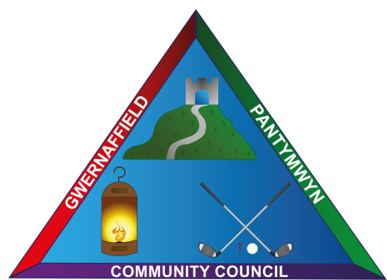
Dear Sir/Madam
You are hereby summoned to a meeting of Gwernaffield and Pantymwyn Community Council at Ysgol Y Waun on Wednesday 5 April 2017 at 7.30pm.
The meeting will consider the agenda items below.

Yours sincerely

Mrs K L Roberts
Clerk to the council

Members of the public and press are welcome to attend.
AGENDA 5 April 2017
- To consider accepting apologies for absence
- To approve the minutes of the last council meeting on 1 March 2017
- To record declarations of interest from members in any item to be discussed
- Parking Issues in Y Waen, Gwernaffield – meeting to discuss a way forward.
- Matters Arising from the last minutes
- Streetscene Matters
- Clerk’s Update and Correspondence
- To consider the Community Council Risk Assessment document and update the asset register for 2017/2018 accordingly.
- Youth Club, Gwernaffield – to discuss issues of concern reported to Flintshire County Council.
- Ysgol Y Waun – to consider a financial contribution toward community centre hire in 2017/2018.
- Annual litter pick in the villages 29 April 2017 - to confirm arrangements and voluntary assistance.
- Community Street Lighting next phase 2017/2018
- Planning Applications (A) Planning Decisions (B)
- To approve payments to be made
- To receive items for the next meeting on Wednesday, 3 May 2017 at Ysgol Y Waun.

